Ash Creek Water Control District
Board Meeting – December 4, 2025
Board meeting begins at 6:30 PM
The meeting will be an in-person event held at Indy Commons.
Zoom will also be available: https://us06web.zoom.us/j/82158510794
- Call to Order
- Roll Call

Brooke Getty
Madeline Fisher
Tom Wilson
Molly Barbano
Lauren Zatkos
Ed Matteo
Todd Whitaker
Amy Albrich
Guests?
(Marilyn Morton, recording)
- Approval of Minutes – September 4, 2025
- Minutes of September meeting (attached)
- Audience Comments
- Director Comments
- Reports
- Finance: Monthly Report
- Phone: Monthly Report
- Nutria: Monthly Report
- Precipitation: Monthly Report
- Engineer’s Report
- Education Grants
- Unfinished Business
- Review of 10 year plan: time for discussion. Access the 10 year plan by visiting: file:///C:/Users/maril/Downloads/ACWCD%2010%20Yr%20Plan%20-%20Final%20(1).pdf
- Consideration of educational grants outside of school district
- Bank account/LGIP signers/authorizations complete?
- Is registration with Secretary of State required by bank?
- Updating Policies & Procedures Manual (a significant amount of time should be dedicated to this activity during the meeting). Work Document attached.
- Any Update on formation of Regional Mid-Willamette West Waterway Partnership
- New Business, Miscellaneous Business/Information Items
- Kevin Porter, District Manager, PSWCD presentation/discussion
- Correspondence
- Establishing a Strategic Planning schedule
- New ADA web requirements for PDF accessibility discussion (copy attached)
10. Adjournment & next meeting

Documents following include:
Minutes from October meeting

Financial recap of latest information available from institutions.

Board of Directors, Positions & Terms

Links for communications from SDAO

Ash Creek Water Control District Minutes, 10-2-25, 6:30 PM, Indy Commons
- Treasurer Tom Wilson called the meeting to order at 6:35 PM
- Roll Call: Brooke Getty, Tom Wilson, Molly Barbano, Ed Matteo, Amy Albrich (online), Todd Whitaker, Marilyn Morton. Absent/Excused: Madeline Fisher, Lauren Zatkos. Note: Emanual Goicochea resigned.
There was not a quorum; this meeting will be Informational Only.
- Minutes of 9-4-25 meeting: Deferred until a quorum is present.
- Audience comments – none
- Director comments:
- Reports
- Tom Wilson gave an informational Treasurer’s/Financial report. Prepaid Visa card will be discussed at the next meeting.
- Phone: Brooke Getty reported there were no calls.
- Nutria: Ed Matteo’s report – 1 nutria caught in Old Town, 2 caught south of Independence (total 3 caught). 53 traps remain out.
- Precipitation:
September 2025 = 1.48"
September 2024 = 0.86"
September 2023 = 2.84"
September 2022 = 0.47"
September 2021 = 2.62"
- Engineer’s Report: Nothing at this time. Rulings regarding FEMA/ endangered species and Draft Environmental Impact Statement discussed. Public comment is currently being accepted about the Impact Statement, which must support a policy of “no net loss of habitat”.
- Education Grants: Checks have been issued on all current grants. Brooke will file all necessary documents and send copies to Tom for posting on the website
- Unfinished Business
- Digital Storage was discussed. Tom explained the access into document storage.
- Name of ACWCD discussed; it must remain as is according to ORS553.
- Bank/LGIP signers’ signatures and information is being gathered. Should be done shortly.
- Regional Mid-Willamette West Waterway Partnership; holding for more information
- New Business
- Update/Review the Policies & Procedures Manual. Note: grants outside of the school district, as previously discussed, must be defined in the updated Policies and Procedure Manual.
- Tom presented a draft; updated manual to be presented at future meeting.
- Correspondence – From Public Works
- 10 year plan: Digital access is at file:///C:/Users/maril/Downloads/ACWCD%2010%20Yr%20Plan%20-%20Final%20(1).pdf.
- Strategic Planning Schedule: Development of plan will occur in November/December. From the completed plan the next biennial budget will be drawn.
- Planning details:
- There must be a resolution for adopting a new Strategic Plan
- The Policies & Procedures Manual must include rescission of any existing plans.
- Todd gave an outline of what a 10-year strategic plan needs to include.
- He said the last map revision was done in 2011-2012, and it focused on Inspiration Gardens.
- Map revisions must reflect current FEMA flood plan maps.
- Todd will be doing a lot of this work in the planning process.
- He suggested board members review Chapter 5 as it will become a template for planning.
- At the next meeting internal budget consideration will begin. The ACWCD’s Budget Committee begin public meetings in February.
- Tom said there are new ADA web requirements for PDF accessibility. These are the new standards for screen readers for the visually impaired. Tom reported that the ACWCD website is already updated.
- Please plan for Russ Cooper, Mark Landau (Monmouth Public Works) & hopefully Gerald Fisher (Independence Public Works) to be in attendance at the next meeting.
- Marilyn informed the board that she met with SDIC/SDAO, an annual process.
- Adjournment & next meeting
- It was moved and seconded to adjourn the meeting at 8:02 PM.
- Next Meeting November 6 at Indy Commons @ 6:30 PM.

REVIEW OF FISCAL YEAR ACTIVITY, PIONEER BANK
 | Date | Credit | Debit | Running Balance
Beginning Balance | 1/1/2025 |  |  | $ 5,950.93
Ascension Accounting | 1/2/2025 |  | $ 249.67 | $ 5,701.26
Ascension Accounting | 1/3/2025 |  | $ 54.00 | $ 5,647.26
2339, Marilyn Morton | 1/8/2025 |  | $ 200.00 | $ 5,447.26
2338, Streaming Annual | 1/10/2025 |  | $ 1,260.00 | $ 4,187.26
2340, SDIS Annual | 1/10/2025 |  | $ 2,780.00 | $ 1,407.26
Xfer from LGIP | 1/14/2025 | $ 5,000.00 |  | $ 6,407.26
Interest | 1/31/2025 | $ 3.63 |  | $ 6,410.89
ACH, Ascension Accounting | 2/5/2025 |  | $ 161.33 | $ 6,249.56
2341, Marilyn Morton fee | 2/6/2025 |  | $ 200.00 | $ 6,049.56
2342, Indy Commons space rental | 2/6/2025 |  | $ 30.00 | $ 6,019.56
2343, Or Sec'ty State Business renew | 2/24/2025 |  | $ 40.00 | $ 5,979.56
Interest earned | 2/28/2025 | $ 3.06 |  | $ 5,982.62
ACH, Ascension Accounting 10017 | 3/4/2025 |  | $ 465.23 | $ 5,517.39
ACH, Ascension Accounting 10038 | 3/4/2025 |  | $ 54.00 | $ 5,463.39
2344, Marilyn Morton fee | 3/5/2025 |  | $ 200.00 | $ 5,263.39
2345, Indy Commons space rental | 3/6/2025 |  | $ 30.00 | $ 5,233.39
Interest earned | 3/31/2025 | $ 2.99 |  | $ 5,236.38
2346, LWC: GW Restoration | 3/31/2025 |  | $ 680.13 | $ 4,556.25
ACH Ascension Accounting 10115 | 3/31/2025 |  | $ 90.00 | $ 4,466.25
2347, Marilyn Morton fee | 4/3/2025 |  | $ 200.00 | $ 4,266.25
2348, Indy Commons (Board mtg) | 4/3/2025 |  | $ 40.00 | $ 4,226.25
ACH Ascention Accounting 10192 | 4/3/2025 |  | $ 54.00 | $ 4,172.25
2349, LWC, Ash Creek Contract | 4/8/2025 |  | $ 14,593.27 | $ (10,421.02)
LGIP ACH Redemption | 4/9/2025 | $ 15,000.00 |  | $ 4,578.98
Interest Earned | 4/30/2025 | $ 2.50 |  | $ 4,581.48
2350, Marilyn Morton fee | 5/1/2025 |  | $ 200.00 | $ 4,381.48
2351, Indy Commons space rental | 5/1/2025 |  | $ 20.00 | $ 4,361.48
2352, Affordable Storage rental | 5/1/2025 |  | $ 605.00 | $ 3,756.48
2353, Tom Wilson, email reimb. | 5/20/2025 |  | $ 559.90 | $ 3,196.58
2354, LWC AC Reneg Contract | 5/28/2025 |  | $ 51,174.53 | $ (47,977.95)
LGIP ACH Redemption | 5/31/2025 | $ 55,000.00 |  | $ 7,022.05
ACH, Ascension Accounting | 5/28/2025 |  | $ 102.75 | $ 6,919.30
2355, Tom Wilson email reimb. | 5/29/2025 |  | $ 64.99 | $ 6,854.31
2356, Marilyn Morton fee | 6/5/2025 |  | $ 200.00 | $ 6,654.31
2357, Independence Nursery/Water Grd | 6/5/2025 |  | $ 600.00 | $ 6,054.31
Interest earned | 5/30/2025 | $ 6.36 |  | $ 6,060.67
ACH, Ascension Accounting | 6/2/2025 |  | $ 54.00 | $ 6,006.67
Ascension Accounting | 6/17/2025 |  | $ 54.00 | $ 5,952.67
Interest earned | 6/30/2025 | $ 12.64 |  | $ 5,965.31
USPS Box 81 | 7/1/2025 |  | $ 210.00 | $ 5,755.31
Polk County Clerk Election Fee | 7/1/2025 |  | $ 4,936.85 | $ 818.46
SAIF Insurance (annual) | 7/1/2025 |  | $ 306.63 | $ 511.83
CNA Surety (annual) | 7/1/2025 |  | $ 500.00 | $ 11.83
LGIP Reimbursemsent | 7/14/2025 | $ 10,000.00 |  | $ 10,011.83
Ascension Accounting | 7/5/2025 |  | $ 141.50 | $ 9,870.33
Ascension Accounting | 7/25/2025 |  | $ 135.00 | $ 9,735.33
Interest | 7/31/2025 | $ 5.33 |  | $ 9,740.66
Roam Forestry | 8/7/2025 |  | $ 7,306.41 | $ 2,434.25
Marilyn Morton | 8/7/2025 |  | $ 200.00 | $ 2,234.25
LGIP Transfer | 8/7/2025 | $ 5,000.00 |  | $ 7,234.25
Ash Creek Elementary Ed. Grant | 8/7/2025 |  | $ 835.00 | $ 6,399.25
Talmadge Middle School Ed. Grant | 8/7/2025 |  | $ 1,000.00 | $ 5,399.25
Ascension Accounting | 8/1/2025 |  | $ 54.00 | $ 5,345.25
Ascension Accounting (2) | 8/25/2025 |  | $ 176.90 | $ 5,168.35
Interest | 8/25/2025 | $ 4.55 |  | $ 5,172.90
LGIP Transfer | 8/30/2025 | $ 10,000.00 |  | $ 15,172.90
Marilyn Morton | 9/4/2025 |  | $ 200.00 | $ 14,972.90
Indy Commons, meeting place | 9/4/2025 |  | $ 60.00 | $ 14,912.90
LWC Reneg. Contract | 9/4/2025 |  | $ 7,870.40 | $ 7,042.50
Marilyn Morton | 10/9/2025 |  | $ 200.00 | $ 6,842.50
Indy Commons, meeting place | 10/9/2025 |  | $ 30.00 | $ 6,812.50
New Checks (delux) | 9/16/2025 |  | $ 33.97 | $ 6,778.53
Interest | 9/30/2025 | $ 4.58 |  | $ 6,783.11
Ascension Accounting (2) | 10/3/2025 |  | $ 78.50 | $ 6,704.61

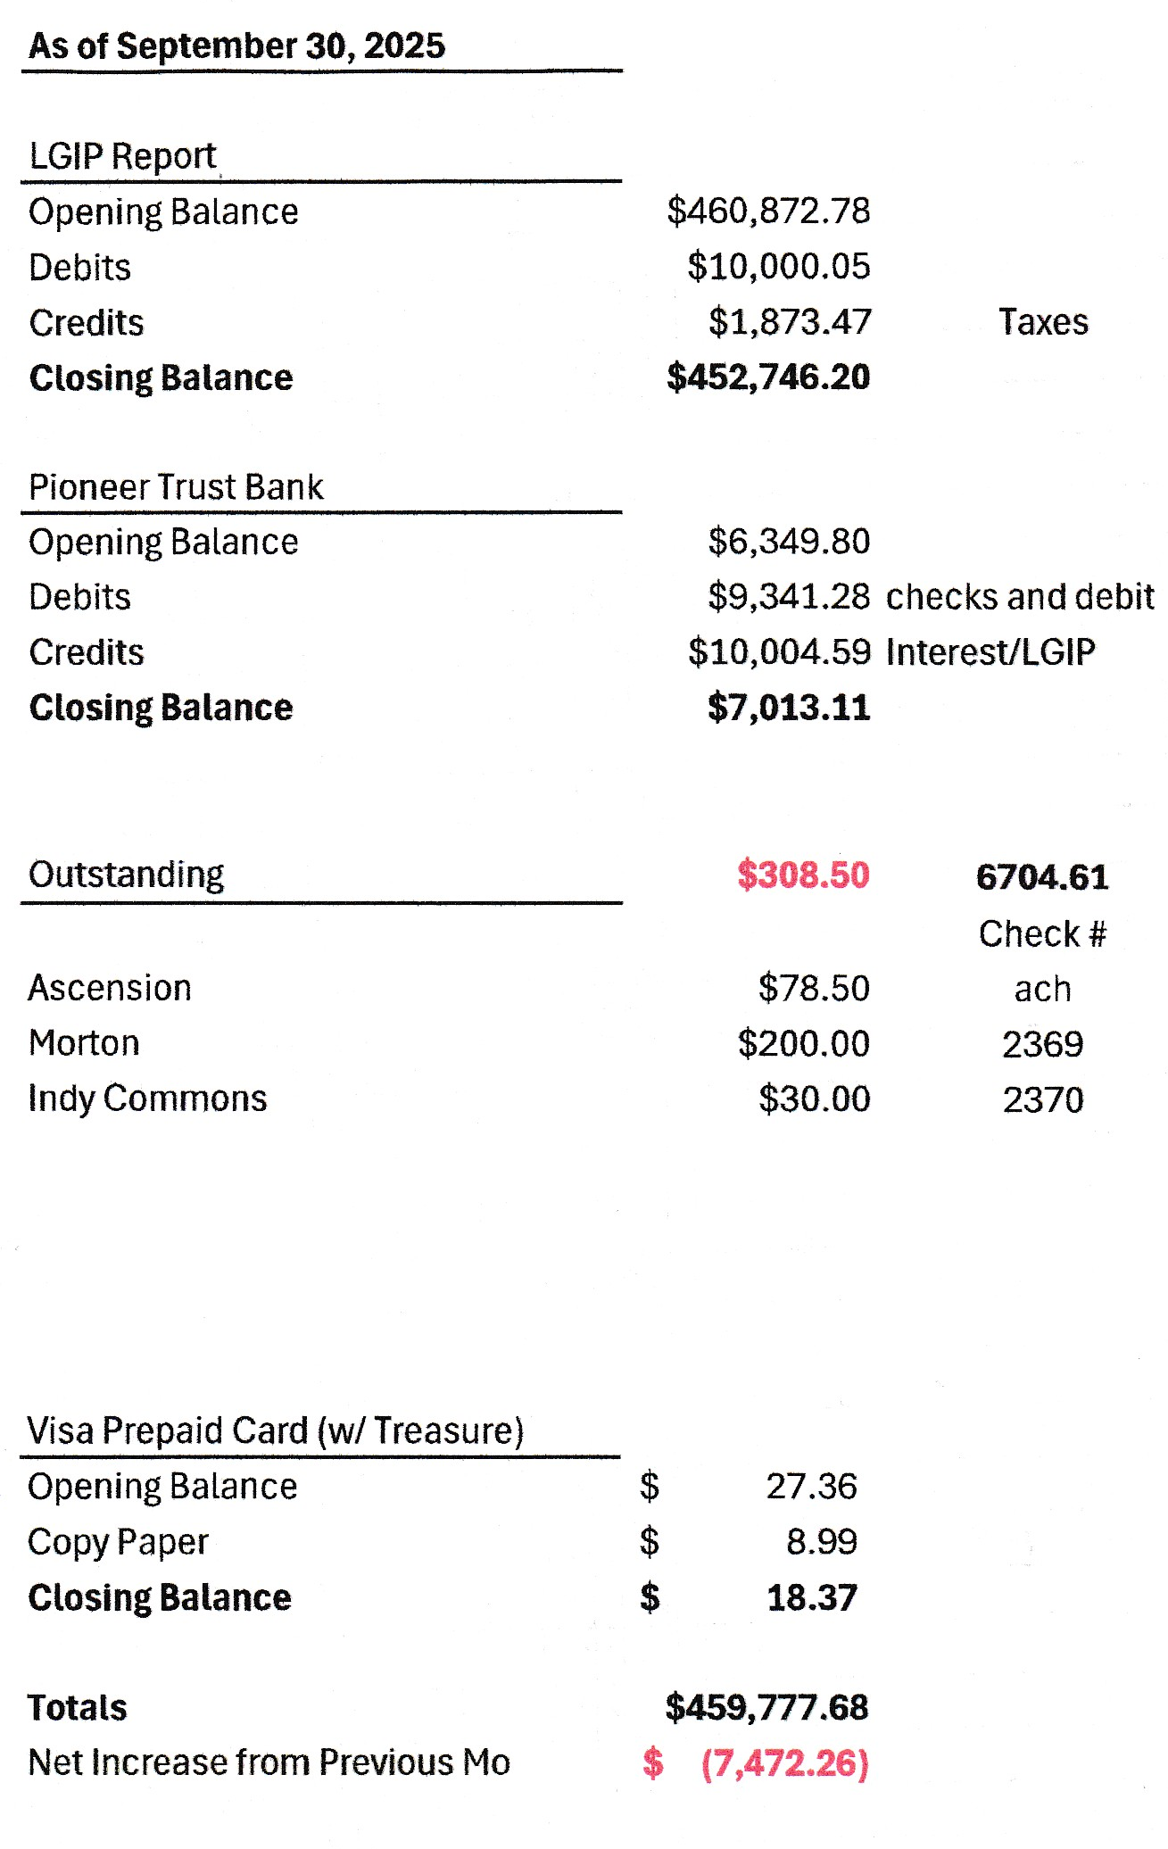
WITH ELECTION RESULTS:
Board of Directors, Positions & Terms after May 20 election

Mailing Address & Phone Number for all Directors:
PO Box 81, Independence, OR 97351, 503 779-9869

Director #1
Tom Wilson, President & Treasurer
Term: 2027
Email: director1@ashcreekwcd.com

Director #2
Vacant
Next election: 2027
Email: director2@ashcreekwcd.com

Director #3
Madeline Fisher
Term expires: 2029
Email: director3@ashcreekwcd.com

Director #4
Molly Barbano
Term expires: 2028
Email: director4@ashcreekwcd.com

Director #5
Brooke Getty
Term expires: 2028
Email: director5@ashcreekwcd.com

Director #6
Ed Matteo, Vice President
Term expires: 2027
Email: director6@ashcreekwcd.com

Director #7
Lauren Zatkos
Term expires: 2029
Email: director7@ashcreekwcd.com

Director #8:
Amy Albrich
Term expires: 2027
Email:
Director8@ashcreekwcd.com

Director #9
Position remains vacant
Term expires: 2029
Email: director9@ashcreekwcd.com

Content/Links for electronic correspondence:
From SDAO:
https://www.magnetmail.net/actions/email_web_version.cfm?ep=aiG7TXw8p6eAbFY-OXtJeeh-YEJi5KifS4hIjg748XoRBQ_mKDFBpF2kc6Wt76jC7RB7T2Kr8CTjTLgky8XzLnuLSJexiycXTRev4Rub_kKHvXdlAh5QrU9ar6DCu4c2
https://www.magnetmail.net/actions/email_web_version.cfm?ep=aiG7TXw8p6eAbFY-OXtJeeh-YEJi5KifS4hIjg748Xq2hgge2HyrzS2VJvs6QnWPIJVMcRcNYdobC8bNgkDHNKu8yb77AqCkEyogesTEYim2RwhNResfg9jLa8Vlmd5K

Sexual Misconduct: file:///C:/Users/maril/Downloads/Sexual%20Misconduct%20Coverage%20(1).pdf
Cyber Coverage Application:
file:///C:/Users/maril/Downloads/Cyber%20Coverage%20(1).pdf

