Ash Creek Water Control District
Board Meeting – August 7, 2025
Board meeting begins at 6:30 PM
The meeting will be an in-person event held at Indy Commons.
Zoom will also be available: https://us06web.zoom.us/j/82158510794
AGENDA, August 7, 2025 meeting
- Call to Order
- Roll Call
Brooke Getty
Madeline Fisher
Tom Wilson
Molly Barbano
Lauren Vatkos
Ed Matteo
Todd Whitaker
Emmanuel Goicochea
Amy Albrich
Lauren Vatkos
Guests?
(Marilyn Morton, recording)
- Election of Officers
- Approval of Minutes – July 10, 2025 (minutes attached)
- Treasurer’s Report
- Audience Comments
- Director Comments
- Reports
- Finance: Monthly Report
- Phone: Monthly Report
- Nutria: Monthly Report
- Precipitation: Monthly Report
- Engineer’s Report
- Education Grants
- Policies & Procedures manual
- Unfinished Business
- Educational grants outside of school district
- Bank account/LGIP signers/authorizations
- Update on formation of Regional Mid-Willamette West Waterway Partnership
- Trestle Cleanup (revisit as needed)
- New Business, Miscellaneous Business/Information Items
- Correspondence
12. Adjournment & next meeting

Documents following include:
Minutes from July meeting

Financial recap of latest information available from institutions.

Board of Directors, Positions & Terms

Links for communications from SDAO

Ash Creek Water Control District Minutes, 7-10-25, 5:30 PM, Indy Commons
- Treasurer Tom Wilson called the meeting to order at 6:30 PM
- Roll Call: Brooke Getty, Madeline Fisher, Tom Wilson, Molly Barbano, Lauren Vatkos, Ed Matteo, Amy Albrich, Anne Scheck. ABSENT: Emanual Goicochea, Todd Whitaker, Marilyn Morton
- Election of officers was not held at this meeting.
- Minutes of 6-5-25 meeting: Ed Matteo moved to approve the minutes as presented, Amy Albrich 2nd, motion passed 7-0.
- Swearing in of new board members was done: Tom Wilson led the swearing in of Lauren Vatkos, Amy Albrich, Brooke Getty, Molly Barbano, and Madeline Fisher. Signed oaths of office were secured.
- Audience comments – none
- Director comments:
- Discussion regarding lack of grant participants due to bad timing for teachers. Open enrollment discussed for future grants. Brooke said she’d like to explore other options for education outside of the school system, i.e. 4H, Boy/Girl Scouts, FFA, Boys and Girls Club, etc. Tom Wilson moved to extend the application window for education grants through September 20, 2025, Molly Barbano seconded. Motion passed 7-0.
- Reports
- Finance Report:
- LGIP Closing Balance: $471, 554.85
- Pioneer Trust Balance: $5,965.31
- Pre Paid Visa Balance: $57.36
- Madeline is working with Brian Dutton from WOU on Emerald Ash Borer Trapping
- Phone: nothing to report
- Nutria: no nutria trapped
- Precipitation:
June 2025 = .45"
June 2024 = 1.07"
June 2023 = .13"
June 2022 = 2.9"
June 2021 = 2.1"
- Engineer’s Report: None
- Education Grants:
Two were submitted:
- Dave Beatley -Talmadge Middle - Life Along Ash Creek (a stop motion story) - $1000
- Emily Blythe - Independence Elem. Bio-Diversity In Bottle - $835
Ed Matteo moved, Amy Albrich second, to approve the two education grants as presented. Passed 7-0.
- Policies & Procedures manual: Tom will reach out to SDAO to set up a training at their earliest conviennce.
- Unfinished Business
- Bank account/LGIP signers/authorizations - Tom will bring the appropriate paperwork to the August meeting.
- Formation of Regional Mid-Willamette West Waterway Partnership - Board will wait and see what the rest of the group does. Not a lot of interest from the board.
- Trestle Cleanup (revisit as needed) - please remove this from the agenda for now.
- Correspondence
  - SDAO training coming up in Salem in September.
  - Annual Conference is next February in Seaside.
- Adjournment & next meeting
- Tom Wilson adjourned meeting at 8:05.
- Next Meeting August 7 at IndyCommons @ 6:30 PM.

Documents following include:
- Financial recap of latest information available from institutions.

Financial Reports for Ash Creek Water Control District for 2025
Pioneer Trust Bank 2025
 |  | Date |  | Credit |  | Debit |  | Running Balance
Pioneer Trust Bank 2025
 |  | Date |  | Credit |  | Debit |  | Running Balance
Beginning Balance |  | 1/1/2025 |  |  |  |  |  | $ 5,950.93
Ascension Accounting |  | 1/2/2025 |  |  |  | $ 249.67 |  | $ 5,701.26
Ascension Accounting |  | 1/3/2025 |  |  |  | $ 54.00 |  | $ 5,647.26
2339, Marilyn Morton |  | 1/8/2025 |  |  |  | $ 200.00 |  | $ 5,447.26
2338, Streaming Annual |  | 1/10/2025 |  |  |  | $ 1,260.00 |  | $ 4,187.26
2340, SDIS Annual |  | 1/10/2025 |  |  |  | $ 2,780.00 |  | $ 1,407.26
Xfer from LGIP |  | 1/14/2025 |  | $ 5,000.00 |  |  |  | $ 6,407.26
Interest |  | 1/31/2025 |  | $ 3.63 |  |  |  | $ 6,410.89
ACH, Ascension Accounting |  | 2/5/2025 |  |  |  | $ 161.33 |  | $ 6,249.56
2341, Marilyn Morton fee |  | 2/6/2025 |  |  |  | $ 200.00 |  | $ 6,049.56
2342, Indy Commons space rental |  | 2/6/2025 |  |  |  | $ 30.00 |  | $ 6,019.56
2343, Or Sec'ty State Business renew |  | 2/24/2025 |  |  |  | $ 40.00 |  | $ 5,979.56
Interest earned |  | 2/28/2025 |  | $ 3.06 |  |  |  | $ 5,982.62
ACH, Ascension Accounting 10017 |  | 3/4/2025 |  |  |  | $ 465.23 |  | $ 5,517.39
ACH, Ascension Accounting 10038 |  | 3/4/2025 |  |  |  | $ 54.00 |  | $ 5,463.39
2344, Marilyn Morton fee |  | 3/5/2025 |  |  |  | $ 200.00 |  | $ 5,263.39
2345, Indy Commons space rental |  | 3/6/2025 |  |  |  | $ 30.00 |  | $ 5,233.39
Interest earned |  | 3/31/2025 |  | $ 2.99 |  |  |  | $ 5,236.38
2346, LWC: GW Restoration |  | 3/31/2025 |  |  |  | $ 680.13 |  | $ 4,556.25
ACH Ascension Accounting 10115 |  | 3/31/2025 |  |  |  | $ 90.00 |  | $ 4,466.25
2347, Marilyn Morton fee |  | 4/3/2025 |  |  |  | $ 200.00 |  | $ 4,266.25
2348, Indy Commons (Board mtg) |  | 4/3/2025 |  |  |  | $ 40.00 |  | $ 4,226.25
ACH Ascention Accounting 10192 |  | 4/3/2025 |  |  |  | $ 54.00 |  | $ 4,172.25
2349, LWC, Ash Creek Contract |  | 4/8/2025 |  |  |  | $ 14,593.27 |  | $ (10,421.02)
LGIP ACH Redemption |  | 4/9/2025 |  | $ 15,000.00 |  |  |  | $ 4,578.98
Interest Earned |  | 4/30/2025 |  | $ 2.50 |  |  |  | $ 4,581.48
2350, Marilyn Morton fee |  | 5/1/2025 |  |  |  | $ 200.00 |  | $ 4,381.48
2351, Indy Commons space rental |  | 5/1/2025 |  |  |  | $ 20.00 |  | $ 4,361.48
2352, Affordable Storage rental |  | 5/1/2025 |  |  |  | $ 605.00 |  | $ 3,756.48
2353, Tom Wilson, email reimb. |  | 5/20/2025 |  |  |  | $ 559.90 |  | $ 3,196.58
2354, LWC AC Reneg Contract |  | 5/28/2025 |  |  |  | $ 51,174.53 |  | $ (47,977.95)
LGIP ACH Redemption |  | 5/31/2025 |  | $ 55,000.00 |  |  |  | $ 7,022.05
ACH, Ascension Accounting |  | 5/28/2025 |  |  |  | $ 102.75 |  | $ 6,919.30
LGIP - State of Oregon, for 2025
 |  | Date |  | Credit |  | Debit |  | Running Balance
Beginning Balance |  | 1/1/2025 |  |  |  |  |  | $ 530,840.29
Polk County Treasury, Tax |  | 1/8/2025 |  | $ 847.00 |  |  |  | $ 531,687.29
Debits, Transfer to checking |  | 1/14/2025 |  |  |  | $ 5,000.00 |  | $ 526,687.29
Polk County Treasury, Tax |  | 2/3/2025 |  | $ 2,125.00 |  |  |  | $ 528,812.29
Polk County Treasury, Tax |  | 3/1/2025 |  | $ 2,120.00 |  |  |  | $ 530,932.29
Polk County Treasury, Tax |  | 4/1/2025 |  | $ 3,280.00 |  |  |  | $ 534,212.29
Polk County Treasury, Tax |  | 4/7/2025 |  | $ 286.05 |  |  |  | $ 534,498.34
ACH Redemption |  | 4/9/2025 |  |  |  | $ 15,000.00 |  | $ 519,498.34
Accrual Income Div Reinvestment |  | 5/1/2025 |  | $ 1,979.04 |  |  |  | $ 521,477.38
Debits, Transfer to checking |  | 5/31/2025 |  |  |  | $ 55,000.00 |  | $ 466,477.38
LGIP Prepaid Visa Card,205
 |  | Date |  | Credit |  | Debit |  | Running Balance
Beginning Balance |  | 1/1/2025 |  |  |  |  |  | $ 247.26
Debits, none to date |  |  |  |  |  |  |  | $ 247.26
Credits, none to date |  |  |  |  |  |  |  | $ 247.26

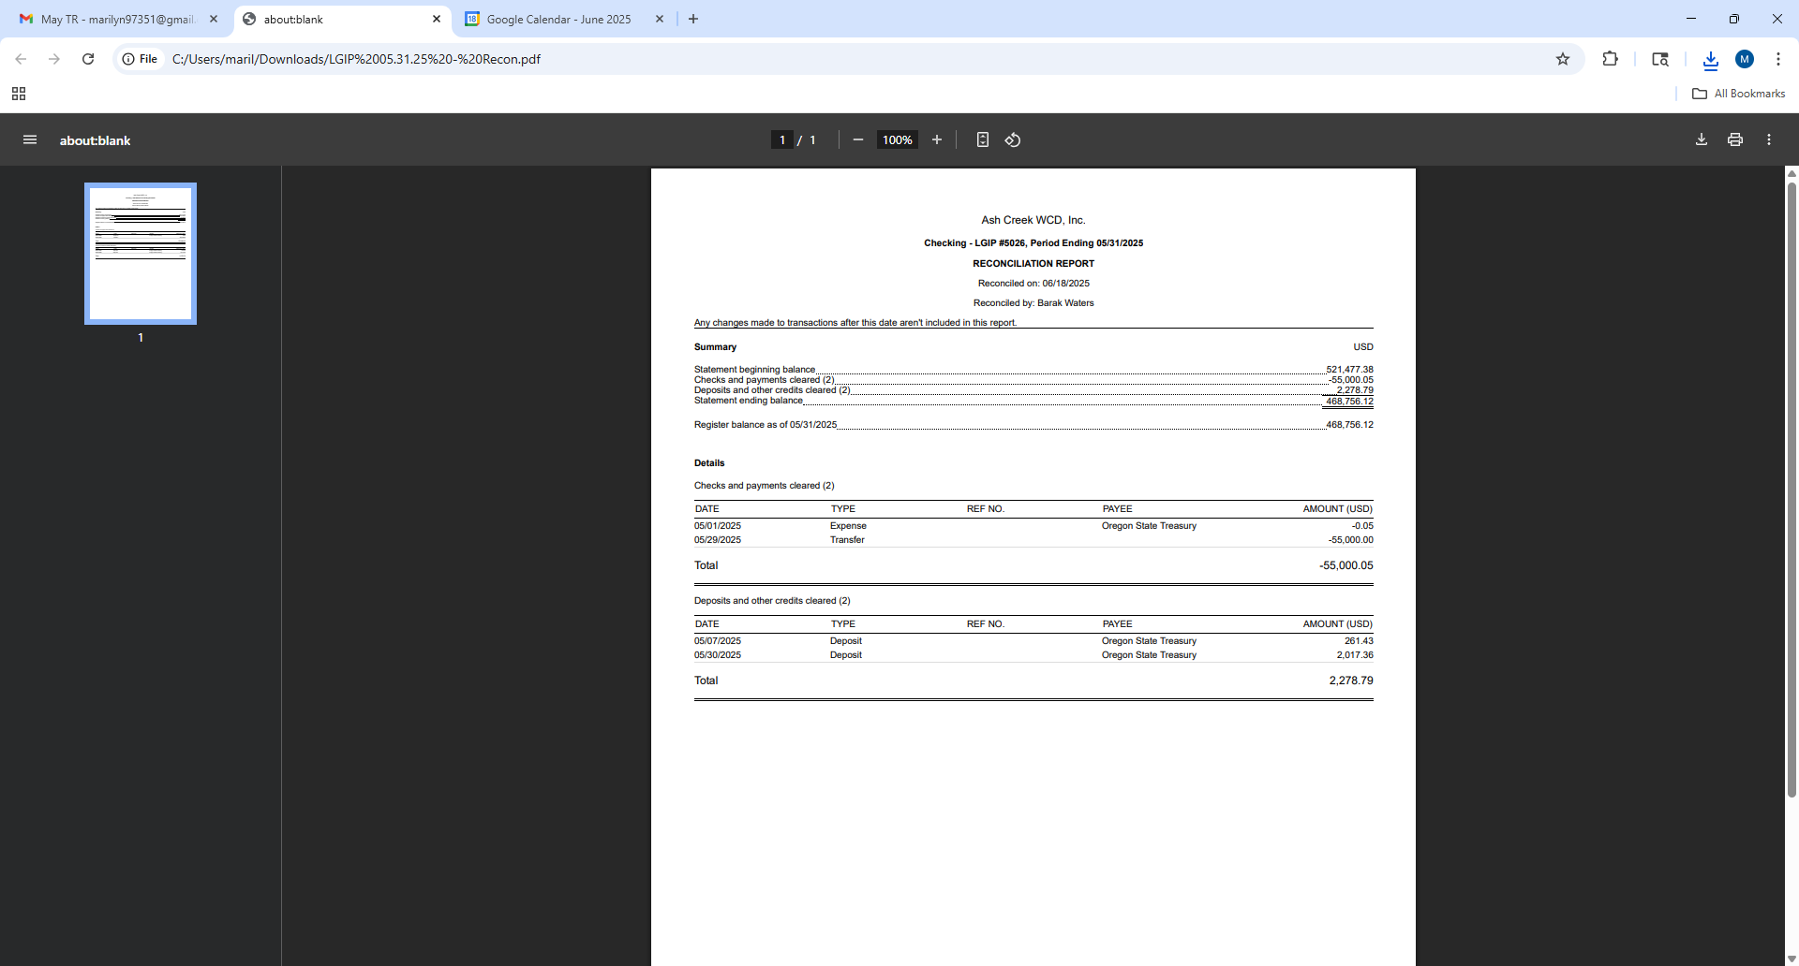
WITH ELECTION RESULTS:
Board of Directors, Positions & Terms after May 20 election

Mailing Address & Phone Number for all Directors:
PO Box 81, Independence, OR 97351
503 779-9869

Director #1
Tom Wilson
Term: 2027
Email: director1@ashcreekwcd.com

Director #2
Emmanuel Goicochea
Term expires: 2027
Email: director2@ashcreekwcd.com

Director #3
Madeline Fisher
Term expires: 2029
Email: director3@ashcreekwcd.com

Director #4
Molly Barbano
Term expires: 2028
Email: director4@ashcreekwcd.com

Director #5
Brooke Getty
Term expires: 2028
Email: director5@ashcreekwcd.com

Director #6
Ed Matteo
Term expires: 2027
Email: director6@ashcreekwcd.com

Director #7
Lauren Vatkos
Term expires: 2029
Email: director7@ashcreekwcd.com

Director #8:
Amy Albrich
Term expires: 2027
Email:
Director8@ashcreekwcd.com

Director #9
Position remains vacant
Term expires: 2029
Email: director9@ashcreekwcd.com

Content/Links for electronic correspondence:
From SDAO:
https://www.magnetmail.net/actions/email_web_version.cfm?ep=WR3zYkspt41BnMmEPt_H_dAwjixEfcDBGW2qLaDnmOgRnacWJvaR_Vb_j9GumBXlQ95AVpMzZh-ctXdrIHvCRHqLVDQSkXVDYSxrc370Wl-b9F1wpTgjmnVW-qt9A4lH
https://www.magnetmail.net/actions/email_web_version.cfm?ep=WR3zYkspt41BnMmEPt_H_dAwjixEfcDBGW2qLaDnmOhBUiQmo8dBRoKy_7dupCEz-9zFONpFZ5nALxqa5hIQX7iV-7Pv0JnwJdGj8JziNRDTsG8RbzTYoriz9JTtoPcV
https://www.magnetmail.net/actions/email_web_version.cfm?ep=WR3zYkspt41BnMmEPt_H_dAwjixEfcDBGW2qLaDnmOjD2vNIIF8H5E91BF4bQAe16LnyZYzPgGjux9zFi43lgguP2dQAvl--SsmWDHzMeCfMRTX405RbcIkQRBZ9juRE
https://www.magnetmail.net/actions/email_web_version.cfm?ep=aiG7TXw8p6eAbFY-OXtJeeh-YEJi5KifS4hIjg748XrWwnyUVFYTUYkGumUApQOYTsl6CyvwlaS34tjlEwHifjN7WJ41nvIEtXcoAsZrhnaQPM3Rx-2Bj9giXI6tSrTi

----- D R A F T -----
MEMORANDUM OF UNDERSTANDING
Mid-Willamette West Waterway Partnership (GROUP NAME???)
(Regional Collaboration for Preservation and Protection of Watershed Health)
Mission: To provide useful information to residents of the region’s community members that demonstrates the importance of protecting local waterways for the beneficial uses of all residents. The partners of the [Name of the group] believe that clean, healthy streams help support thriving, healthy communities. Watershed health is achieved by the actions and behaviors of an engaged population. We will work together to create a positive, impactful experience that will drive environmentally sound practices within our communities.
Goal: The goal of this collaborative effort is to demonstrate that a unified regional voice can effectively share environmental messaging, reaching a broader audience than individual efforts alone. The [Name of the group] will focus on sharing resources to develop and promote public events that educate community members about local water resources and how to protect them. Resources may include such as: staff time, tools, equipment, technical expertise, participation, funding, or other support.
Partners: Local governments, watershed councils, and special districts are encouraged to join this collaborative effort to help build strong, lasting relationships. Together, we share a commitment to improving watershed health and protecting the regional environment. This project aims to Increase public awareness and community involvement in local waterway stewardship efforts.
Participation Expectations: Partners are invited to contribute resources, offer feedback, and support project initiatives as appropriate. The group will collaborate to establish a mutually agreeable schedule and determine how each partner can best contribute to the overall success of the projects.
Core Event: The [Name of the group] will organize and host at least 1 public core event annually that will serve as a focal point for the group’s efforts. The intent of the event will be to promote an aspect of watershed health that is of benefit to the audience. The objective is to establish a recognizable event that will draw new and established participation from year to year. The group may also develop other related events or provide support for existing established events that support regional watershed health education.
Logos and Permissions: An electronic version of each organization’s logo should be included in any shared project materials, and on any approved promotional material for individual websites. Shared logos help to promote the collective efforts and activities of all participating groups.
Duration: Ongoing until amended by the group.
Signatures:

