Ash Creek Water Control District, AGENDA

Board Meeting – June 4, 2026
Board meeting begins at 6:30 PM
This is an in-person meeting at Indy Commons. To join by Zoom, please use this link:
https://us06web.zoom.us/j/82158510794?pwd=zBEajDFo31FeaehdbuRWLOkQoafd5S.1
- Call to Order
- Roll Call

Madeline Fisher
Tom Wilson
Molly Barbano
Lauren Zatkos
Ed Matteo
Christine Tinsdell
Todd Whitaker
Guests?
(Marilyn Morton, recording)

- Minutes of May meeting (attached)
- Audience Comments
- Director Comments
- Reports
- Finance: Monthly Report
- Phone: Monthly Report
- Nutria: Monthly Report
- Precipitation: Monthly Report
- Engineer’s Report
- Education Grants
- Unfinished Business
Budget Calendar
Budget Message
Proposed 2026-2028 Biennium Budget for approval (includes approval of budget, approval of current tax rate of $.1069/$1,000 assessed value, and acceptance of tax payments from Polk County). This budget was considered in meetings of the Budget Committee and 5-14-26 and 5-21-26, and was fully approved by the Budget Committee.
Resolution #2026-01, Adopting the Budget
- New Business
- Adjournment & next meeting: July meeting 7-2-2026

Documents following include:
Minutes from May meeting

Budget Calendar and Budget Message for Fiscal Years 2026-2028

Copy of 2026-2028 Budget approved by Budget Committee

Resolution adopting the budget

Financial recap of latest information available from institutions.

Board of Directors, Positions & Terms

Links for communications from SDAO & others

Oath of office, if needed

Ash Creek Water Control District, Minutes
Board Meeting – May 7, 2026
Board meeting begins at 6:30 PM
This is an in-person meeting at Indy Commons. To join by Zoom, please use this link:
https://us06web.zoom.us/j/82158510794?pwd=zBEajDFo31FeaehdbuRWLOkQoafd5S.1
- Meeting was called to order by President at 6:36 PM
- New Board Member: Tom Wilson moved to approve Christine Tinsdale’s board membership, Ed Matteo 2nd, motion passed unanimously. Christine Tinsdell was sworn in. She will be Director #2.

- Present: Madeline Fisher, Tom Wilson, Molly Barbano, Ed Matteo, Christine Tinsdell, Amy Albrich (online), Todd Whitaker, Jordan Perez (Luckiamute Watershed Council), Mancil Russell (former director). Not present: Lauren Zatkos, Brooke Getty. The President declared a quorum was present. Marilyn Morton recording
- Minutes of the April meeting: Ed moved to approve the minutes, Madeline 2nd, motion passed unanimously.
- Update on Certificate of insurance for Storage Unit. Tom reported that WHA has now insured the contents of the storage unit (which the facility was requiring) at the rate of $15/year. The storage unit was imposing a $30/month fee for same. He discussed the need for an audit at the close of the 2024-2026 biennium, and estimated the cost (to be included in the 2026-2028 budget) to be $5,000.
- Audience Comments.
Jordan discussed ACWCD presence at Saturday Market, and also give-away of about ten pair of free shears at another event.
- Director Comments
- Mancil turned in a t-shirt. Tom reminded that ACWCD has hats and shirts for board members.
- Madeline called about removing invasive foliage east of 99W; there is concern about the method and timing of removal and replacement. Jordan discussed easement policies.
- Reports
- Finance: Monthly Report. Tom Wilson gave the financial report and reviewed earnings and expenditures. The Luckiamute project is closed for the 2024-2026 budget biennium.
- Phone: Monthly Report. Phone minutes have lapsed. No calls. Discussion about viability of phone; it was decided to keep it. Tom said Molly will have the phone next. More minutes are needed.
- Nutria: Monthly Report. 52 traps are out, 2 nutria were caught.
- Precipitation: Monthly Report
April 2021, .39”
April 2022, 5.68”
April 2023, 6.25:
April 2024, 1.54”
April 2025, 1.56”
April 2026, 3.43”
- Engineer’s Report – Todd Whitaker said the report is currently in process. It will reference Chapter 5. The budget will likely be near the same as for the 2024-2026 biennium. He reminded the board that the 10-year plan must be completed by the July meeting.
- Education Grants – No report
- Unfinished Business
- Continue Biennium Budget Work: The first budget committee meeting will be Thursday, May 14, at 6:30 PM in Indy Commons. That meeting was noticed in the 5-6-26 newspaper, and will be noticed again on 5-13-26.
- Local residents who have agreed to be on the Budget Committee include:
Donna Horn
Joe Fisher
Mark Barbano
Olivia Matteo
Andrea Melendy
Donna Schuyler
Dan Farnworth
Kevin Porter
- Luckiamute Watershed Council Spring Social: Madeline report the event was excellent. ACWCD received an award, which Lauren will bring to a future meeting.

- Report on Luckiamute Watershed Council Spring Social, April 11?
- New Business
Need for Board members: two of the board members are no longer qualified for membership as they have moved out of the area: Brooke Getty and Amy Albrich. With their departure and the addition of Christine Tinsdell, the board now has 6 of 9 positions filled.
- Adjournment & next meeting. Meeting adjourned at 7:47 PM. The next meetings are: Budget Meeting 5-14-2026, June meeting 6-4-2026, both at Indy Commons

ASH CREEK WATER CONTROL DISTRICT

BUDGET CALENDAR
FY 2026-28, Adopted by BOD 4-2-26

1. Budget Officer Appointed March 5, 2026

2. Proposed Budget Prepared March/April, 2026

3. Budget Officer Publishes Notice (2x) May 6 & May 13, 2026
'Notice of Budget Committee Meeting'

4. Budget Committee Meets, 6:30 p.m. May 14, 2026, 6:30 PM, Indy Commons, & May 21, 2026, 6:30 PM, via Zoom

5. Budget Committee Approves Budget No later than mid-May 2026

6. Notice Published Between May 22 and June 4
'Budget Summary and Notice of (in I-O 5/27, 6/3)
Budget Hearing'

7. Budget Hearing Held June 4, 2026 (regular mtg date)
Budget Adopted, Appropriations Made, (Budget must be adopted NLT
Taxes Imposed & Categorized 6/30)

8. Taxes Certified to County Assessor No later than July 15, 2026

9. Copy of Budget to County Clerk No later than Sept. 30, 2026

Budget Document FY 2026-28 Adopted by Committee 5.21.26.xlsx

For more information please contact the Budget Officer via Email.

BUDGET MESSAGE FROM THE BUDGET OFFICER

The Budget Document is a financial plan, containing estimates of revenues and expenditures for the 2 upcoming fiscal years, which begin July 1, 2026 and end June 30, 2028. Oregon Budget Law allows the creation of a biennial budget and has specific guidelines for preparing, adopting and using the budget. Ash Creek Water Control District first utilized a biennial budget for the period July 1, 2004-June 30, 2006.

The budget is assembled by the appointed Budget Officer, who then prepares a budget message and delivers the message and document to the Budget Committee at an advertised meeting open to the public. The District Board appointed Marilyn Morton as the Budget Officer, who then prepared a Budget Calendar. The meeting was published twice in the Polk Itemizer-Observer.

According to Budget Law, the Budget Message must, at a minimum:
1. Explain the budget document;
2. Include a brief description of the proposed financial policies of the district for the coming fiscal year;
3. Describe the important features of the budget document in connection with the financial policies of the district;
4. Explain reasons for changes from the previous year in appropriations and revenues;
5. Explain major changes in financial policy.

Once the budget has been examined and any changes have been made, the Budget Committee votes to approve the budget. This document will then be published in the format required under Budget Law, and the District will hold a final hearing to adopt the budget. Once the budget has been approved by this budget committee, the District Board may make limited changes to the budget – the Board can decrease the budget by any amount, but it cannot increase the budget expenditures by more than $5,000 or 10%. If the Board desires to increase expenditures by more than this amount, then the budget must be republished, keeping in mind the June 30th adoption deadline.

The Ash Creek Water Control District was formed August 16, 1951, by petition and order, and also falls under Oregon Revised Statutes, Section 553.

The budget for the Ash Creek Water Control District is composed of the General Fund, which is sufficient to carry out the purposes as adopted by local order and state law and a Reserve Fund, which was established to fund large-scale projects within the district.

Financial policy will not substantially change in the new fiscal year: internal cash controls will remain in place; excess’ cash will be deposited in the Local Government Investment Pool until required; and expenditures are allotted to projects within the District boundary, or for projects outside the boundary that affect the District. The District operates on a cash basis of accounting and will continue to do so.

An accounting firm (Ascension Accounting) was hired to assist the District with bookkeeping and accounts payable; continued and possible additional use of the firm’s expertise is anticipated.

General Fund

Significant budgeting in this fiscal biennium includes amounts to cover potential projects in:
10-year Plan:
1. Knowledge Based: $10,000
2. Physical/Dedicated: $ 200,000
3. Physical/Other: $15,000
Projects – Other: $25,000
1. Education Grants - $10,000
2. Outreach - $2,000
3. Garbage Cans - $1,500
4. Nutria - 1,500
5. Spray - $10,000

A Project Reserve Fund was established by the Board resolution in June 2020, where funds are transferred from the General Fund and reserved for future specified projects. No projects are anticipated to be identified for use by the reserve fund in this fiscal year.

However, the reserve has been allocated to contingency, should a need arise in the next budget biennium. This would require a supplemental budget to access. Also, as done in the previous budget biennium, the proposed budget includes a contingency amount and no unappropriated ending fund balance.

I would like to thank the Budget Committee members for their time and effort in participating in this important process.

Respectfully Submitted,
Marilyn Morton, Budget Officer

BIENNIUM BUDGET APPROVED BY THE BUDGET COMMITTEE, 5-21-26, submitted to ACWCD Board for final consideration

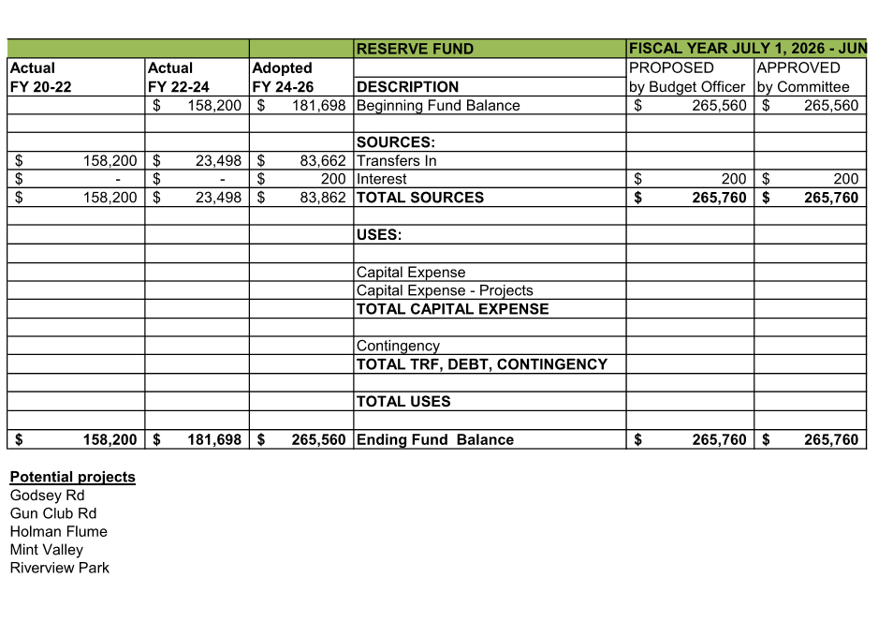

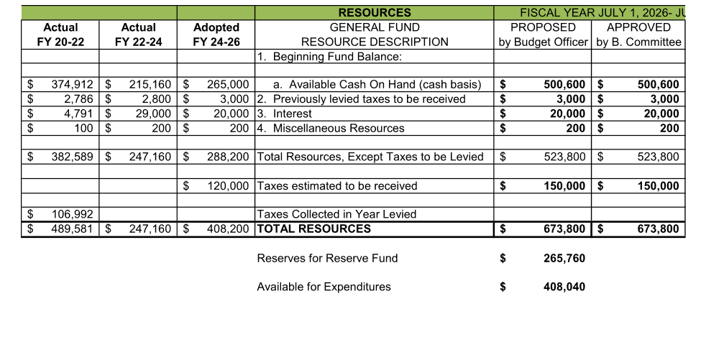

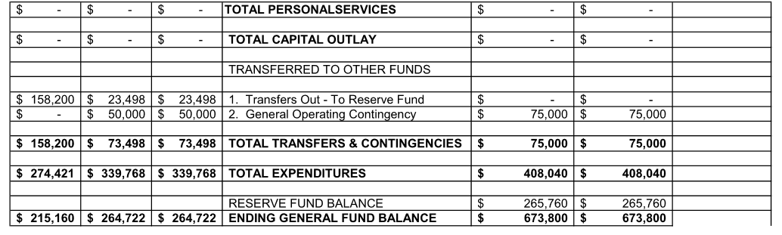
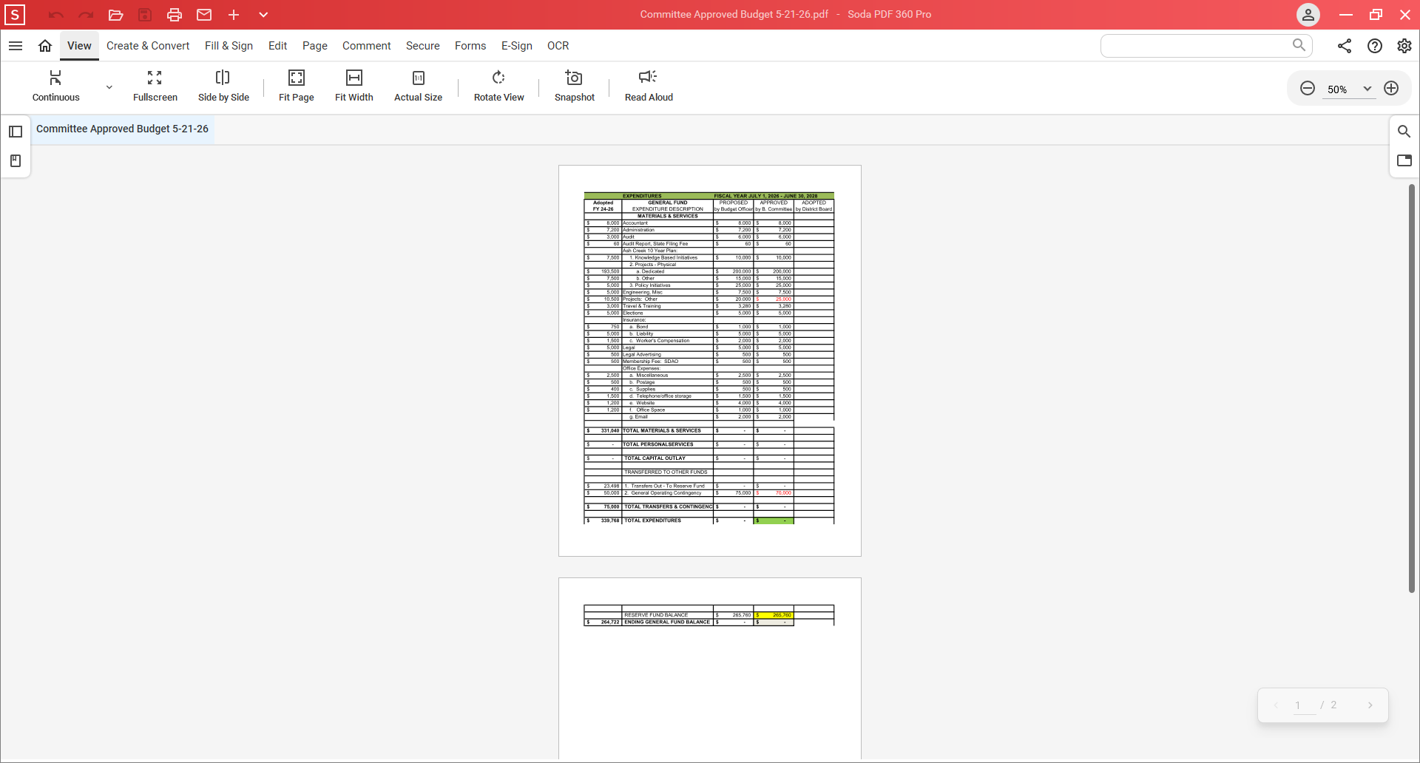
Checkbook Register, ACWCD, 2026
Interest | 11/29/2025 |  | $ 10.49 |  |  |  | $ 6,059.42
Marilyn Morton | 12/8/2025 |  |  |  | $ 200.00 |  | $ 5,859.42
Indy Commons, meeting place | 12/8/2025 |  |  |  | $ 30.00 |  | $ 5,829.42
Ascension Accounting (4) | 12/8/2025 |  |  |  | $ 142.40 |  | $ 5,687.02
Gift Card Purchase (Tom Wilson) | 12/8/2025 |  |  |  | $ 500.00 |  | $ 5,187.02
Interest | 12/31/2025 |  | $ 1.85 |  |  |  | $ 5,188.87
SDAO | 1/1/2026 |  |  |  | $ 266.00 |  | $ 4,922.87
Streamline - Doc Access | 1/1/2026 |  |  |  | $ 600.00 |  | $ 4,322.87
Streamline - Website | 1/1/2026 |  |  |  | $ 1,320.00 |  | $ 3,002.87
LGIP Redemption | 1/5/2026 |  | $ 10,000.00 |  |  |  | $ 13,002.87
Marilyn Morton (Jan Pay) | 1/8/2026 |  |  |  | $ 200.00 |  | $ 12,802.87
Mungo Signs | 1/8/2026 |  |  |  | $ 364.00 |  | $ 12,438.87
Whitaker Engineering | 1/13/2026 |  |  |  | $ 1,937.50 |  | $ 10,501.37
Ascension Accounting (6582) | 1/17/2026 |  |  |  | $ 161.60 |  | $ 10,339.77
Ascension Accounting (6654) | 1/17/2026 |  |  |  | $ 145.60 |  | $ 10,194.17
Ascension Accounting | 1/17/2026 |  |  |  | $ 58.50 |  | $ 10,135.67
Correction | 1/31/2026 |  | $ 10.00 |  |  |  | $ 10,145.67
Ascension Accounting (11040) | 2/9/2026 |  |  |  | $ 58.50 |  | $ 10,087.17
Marilyn Morton | 2/5/2026 |  |  |  | $ 200.00 |  | $ 9,887.17
Government Ethics Commission | 2/5/2026 |  |  |  | $ 149.73 |  | $ 9,737.44
SDIS Liability | 5/21/1908 |  |  |  | $ 3,064.00 |  | $ 6,673.44
Interest | 1/30/2026 |  | $ 2.87 |  |  |  | $ 6,676.31
Ascension Accounting (10999) | 1/6/2026 |  |  |  | $ 58.50 |  | $ 6,617.81
Marilyn Morton | 3/9/2026 |  |  |  | $ 200.00 |  | $ 6,417.81
Tom Wilson Reimbursement | 3/13/2026 |  |  |  | $ 69.95 |  | $ 6,347.86
Interest | 2/27/2026 |  | $ 2.27 |  |  |  | $ 6,350.13
Ascension Accounting (6737) | 3/4/2026 |  |  |  | $ 290.20 |  | $ 6,059.93
Ascension Accounting (6826) | 3/24/2026 |  |  |  | $ 180.00 |  | $ 5,879.93
Ascension Accounting (11079) | 3/3/2026 |  |  |  | $ 58.50 |  | $ 5,821.43
Interest | 3/31/2026 |  | $ 2.37 |  |  |  | $ 5,823.80
Marilyn Morton | 4/5/2026 |  |  |  | $ 200.00 |  | $ 5,623.80
LWIC: FogW Revegetation | 3/10/2026 |  |  |  | $ 453.00 |  | $ 5,170.80
Affordable Storage | 5/15/2026 |  |  |  | $ 635.00 |  | $ 4,535.80

Board of Directors, Positions & Terms, updated May, 2026

Mailing Address & Phone Number for all Directors:
PO Box 81, Independence, OR 97351, 503 779-9869

Director #1
Tom Wilson, President & Treasurer
Term: 2027
Email: director1@ashcreekwcd.com

Director #2
Christine Tinsdell
Term: 2027
Email: director2@ashcreekwcd.com

Director #3
Madeline Fisher
Term expires: 2029
Email: director3@ashcreekwcd.com

Director #4
Molly Barbano
Term expires: 2028
Email: director4@ashcreekwcd.com

Director #5
Position vacant
Term expires: 2028
Email: director5@ashcreekwcd.com

Director #6
Ed Matteo, Vice President
Term expires: 2027
Email: director6@ashcreekwcd.com

Director #7
Lauren Zatkos
Term expires: 2029
Email: director7@ashcreekwcd.com

Director #8:
Position vacant
Term expires: 2027
Email:
Director8@ashcreekwcd.com

Director #9
Position vacant
Term expires: 2029
Email: director9@ashcreekwcd.com

Content/Links for electronic correspondence:
From SDAO:
https://www.magnetmail.net/actions/email_web_version.cfm?ep=aiG7TXw8p6eAbFY-OXtJeeh-YEJi5KifS4hIjg748XojD1pbPs7nRemkbbMqan5z-ENzWq86pAYCp-l2-9I2A2NvWPy7J8NE-_Qjp9cvXqxqyyVCxm0ivlj2pLmB2MFA
https://www.magnetmail.net/actions/email_web_version.cfm?ep=aiG7TXw8p6eAbFY-OXtJeeh-YEJi5KifS4hIjg748XpQ-go35vqBakp0KBTbIiW_uQRrtD4UVevSChu9VRt4YqZX7IC4nYokbqvOBg0SLw5dvAVYun_dlwTYKCBuUOXq
https://www.magnetmail.net/actions/email_web_version.cfm?ep=aiG7TXw8p6eAbFY-OXtJeeh-YEJi5KifS4hIjg748Xq7Ai5CEHBOPwOR3LKoCtKLbwZQyzXdBL3lAiefQ-Ws7A3P3fRXcbnyra_bLvo4lDf46rX7ACQMIOpX7X5kKrNK
https://www.magnetmail.net/actions/email_web_version.cfm?ep=aiG7TXw8p6eAbFY-OXtJeeh-YEJi5KifS4hIjg748XqTuejKDrvP4JuBgcqw3J3hWH55YiGLsVYeoKBDTeNuNikYmdK1qWRNbv1AYtNUMYwtkgELKBt1bBwPjDWZxar2
https://www.magnetmail.net/actions/email_web_version.cfm?ep=aiG7TXw8p6eAbFY-OXtJeeh-YEJi5KifS4hIjg748Xq5do09NZ1pq1B7OnILzp7-bFVUbZ1PiqFTHKGCShrRuGKLbh_Xe79mOeuSUUiy8TC84JnsCIwYjNhOel-mpBhD
https://www.magnetmail.net/actions/email_web_version.cfm?ep=aiG7TXw8p6eAbFY-OXtJeeh-YEJi5KifS4hIjg748Xqlu0eXM1QjYvKkOaqM-P_D0M4IB3RVWjZDdtEXBtLCVAxtyTX3zwsRmclIJO6tjbm2Gv6i9GFXRyV2_PVVf91X
https://www.magnetmail.net/actions/email_web_version.cfm?ep=aiG7TXw8p6eAbFY-OXtJeeh-YEJi5KifS4hIjg748XrRfWBX0SJkJNf8BpmXMXMKKA-gbc6ueYYFfXvEs3DFeutbndLIcbce5jub-yf8gRzKjKKZyAlVlx16kXIV3aTS

Oath of Office

I, _______________________________, do solemnly swear, that I will support the Constitution of the United States, the Constitution of the State of Oregon, the laws thereof, and the policies of the Ash Creek Water Control District, and that I will faithfully discharge the duties of Director according to the best of my ability, so help me God.

Done, this ______ day of ________________________

__________________________________________

Attest:

________________________________________
Name

________________________________________
Title

ASH CREEK WATER CONTROL DISTRICT
Resolution #2026-01 - RESOLUTION ADOPTING THE BUDGET

BE IT RESOLVED THAT the Board of Directors of the Ash Creek Water Control District hereby adopts the budget for FY 2026-2028 in the total of $673,800 now on file with the ACWC District at distsec@ashcreekwcd.com or on our website.

RESOLUTION MAKING APPROPRIATIONS

General Fund
Personal Services $0
Materials & Services $333,040
Capital Outlay $0
Transfers $0
Contingency $75,000
Total $408,040

Project Reserve Fund
Personal Services $0
Materials & Services $0
Capital Outlay $0
Transfers $0
Contingency $0
Total $0
Debt Service Fund $0

TOTAL APPROPRIATIONS
ALL FUNDS $408,040
UNAPPROPRIATED ENDING FUND BALANCE AND RESERVES $265,760

RESOLUTION IMPOSING THE TAX
BE IT RESOLVED THAT the following ad valorem property taxes are hereby imposed for tax year 2026-27 and 2027-28 upon the assessed value of all taxable property within the district:
- At the rate of $.1069 Per $1000 of assessed value for permanent tax rate.

RESOLUTION CATEGORIZING THE TAX
BE IT RESOLVED THAT the taxes imposed for FY 2026-27 and FY 2027-28 are hereby categorized for the purposes of Article XI section 11b as:

General Government Limitations Excluded from Limitation
Tax Year 2026-27
General Fund $.0169 / $1000 $0
Debt Service Fund $0 $0
Tax Year 2027-28
General Fund $.0169 / $1000 $0
Debt Service Fund $0 $0

The above resolution statements were approved and declared adopted on the 6th day of June 2026.

Tom H. Wilson ___________________________
Chair Signatur

