Ash Creek Water Control District, AGENDA
Board Meeting – January 8, 2026
Board meeting begins at 6:30 PM
The meeting is an in-person event at Indy Commons with a Zoom option.
Zoom will also be available: https://us06web.zoom.us/j/82158510794
- Call to Order
- Roll Call

Brooke Getty
Madeline Fisher
Tom Wilson
Molly Barbano
Lauren Zatkos
Ed Matteo
Todd Whitaker
Amy Albrich
Guests?
(Marilyn Morton, recording)

- Minutes of December meeting (attached)
- Audience Comments
- Director Comments
- Reports
- Finance: Monthly Report
- Phone: Monthly Report
- Nutria: Monthly Report
- Precipitation: Monthly Report
- Engineer’s Report
- Education Grants
- Unfinished Business
Working on the 10-year strategic plan/Policies and Procedures manual: presentations by City of Independence Public Works and Elizabeth Sagmyer
(A work session for the Policies & Procedures and 10-year plan (with particular focus on Chapter 5) is planned for February
Secretary of State registration
Update on Trash Can signage replacement
Any action on new ADA web requirements for PDFs?
- New Business
10. Adjournment & next meeting

Documents following include:
Minutes from December meeting

Financial recap of latest information available from institutions.

Board of Directors, Positions & Terms

Links for communications from SDAO

Ash Creek Water Control District, MINUTES
Board Meeting – December 4, 2025
Board meeting begins at 6:30 PM
The meeting was an in-person event held at Indy Commons with a Zoom option.
- Call to Order: Tom Wilson declared a quorum and opened the meeting at 6:34 PM.
- Roll Call. Board members present or online include: Brooke Getty, Madeline Fisher, Tom Wilson, Lauren Zatkos, Ed Matteo, and Amy Albrich. Excused board member(s): Molly Barbano. Guests: Mark Landau, Kevin Porter, Christina and Nate Tisdall. Marilyn Morton recording.
- Approval of Minutes of September 4, 2025: Amy moved to approve the minutes of 9-24-25, Ed 2nd, motion passed unanimously.
- Audience Comments – guests introduced themselves and gave reasons for attending the meeting
- Director Comments: none
- Reports
- Finance: Monthly Report. Tom presented the financial reports through the end of October. He noted that ACWCD received $55,000-$60,000 per year from property taxes. He noted the need for a new prepaid credit card. Ed moved to approve purchase of a $500 prepaid credit card to pay for the meeting space at Indy Commons and other incidental charges. Madeline 2nd, motion passed unanimously.
- Phone: Monthly Report: Molly reported no calls of note
- Nutria, Monthly Report: Ed reported 2 nutria caught in Monmouth, 1 in Independence. He delivered a printed report.
- Precipitation: Monthly Report from Madeline
November 2025, 4.65”
November 2024, 8.35”
November 2023, 4.11”
November 2022, 6.42”
November 2021, 5.93”
- Engineer’s Report: None
- Education Grants: The committee is working on connecting with Ash Creek Elementary School to deliver the latest check.
- Correspondence: nothing of note
- Information presented by meeting guests:
Mark Landau, Operations Manager for Monmouth Public Works, discussed management of sewer/streets in storms. He also described work done by a RARE student with MPW who was working on a traveling information cart for sharing, and long-term tree planting (3,607 trees and shrubs planted).
Kevin Porter is District Manager for Polk Soil & Water Conservation District. He serves the whole county, oven overlapping with ACWCD coverage. Current project is working on the flow of mercury in the Salt Creek & Ash Creek Swale area.
Christine & Nate Tisdall are interested in water regulation and discharge and in drinking water systems and environmental health in Polk County.
- Unfinished Business
- Consideration of educational grants outside of school district: this item has been moved for discussion on the long range business plan.
- Establishing a Planning Schedule for the 10-year strategic plan/Policies and Procedures manual:
There is a draft of the plan in full crafted from the SDAO template, which outlines required sections and procedural rules. Chapter 5 is, per Tom, the critical section for consideration by ACWCD.
January, presentations by City of Independence Public Works and Elizabeth Sagmyer
February, work session for the Policies & Procedures and 10-year plan (with particular focus on Chapter 5)
March, continue with work on the plans, aiming for approval and adoption.
Amy moved to accept the draft of the 10-year and policies and procedures plan as the working document for ACWCD. Brooke 2nd, motion passed unanimously.
- Is registration with Secretary of State required by bank? Marilyn Morton will prepare a packet for Secretary of State registration at the next ACWCD board meeting.
- Trash Can signage replacement: Ed reported there are 4 trans can signs needing to be replaced of the 6 currently in use. The cost for each metal sign is $91. Tom moved to allocate $364 to replace signs on the identified garbage cans on which updates are needed. Amy 2nd the motion, it passed unanimously.
- No action taken yet on new ADA web requirements for PDFs
- New Business, Miscellaneous Business/Information Items
- Kevin Porter, District Manager, PSWCD presentation/discussion He presented a slide show about what PSWCD and AWCD have in common, and how they work together. Community engagement aspects were discussed
- He reviewed the following:
Contact information
The mission, vision and values of PSWCD
The strategic implementation areas for 2014-2024
Where funding comes from
Available equipment for monitoring
He also answered a variety of questions posed by the board members
A new program is the Focused Ag Solution Programs, and how growers can be involved
Kevin also works with OSU Extension (Derek Godwin)
A quarterly magazine is distributed by PSWCD
Local work groups were also discussed, generally happening in January and February. Brooke and Tom are both interested in those
- Budget Committee: Tom reminded the board that a budget committee will be forming, consisting of an equal number of board members and community members.
- Adjournment: Tom called the meeting adjourned at 7:51 PM. The next meeting will be January 8, 6:30 PM, at Indy Commons.

Pioneer Trust Bank 2025
 | Date | Credit | Debit | Running Balance
Beginning Balance | 1/1/2025 |  |  | $ 5,950.93
Ascension Accounting | 1/2/2025 |  | $ 249.67 | $ 5,701.26
Ascension Accounting | 1/3/2025 |  | $ 54.00 | $ 5,647.26
2339, Marilyn Morton | 1/8/2025 |  | $ 200.00 | $ 5,447.26
2338, Streaming Annual | 1/10/2025 |  | $ 1,260.00 | $ 4,187.26
2340, SDIS Annual | 1/10/2025 |  | $ 2,780.00 | $ 1,407.26
Xfer from LGIP | 1/14/2025 | $ 5,000.00 |  | $ 6,407.26
Interest | 1/31/2025 | $ 3.63 |  | $ 6,410.89
ACH, Ascension Accounting | 2/5/2025 |  | $ 161.33 | $ 6,249.56
2341, Marilyn Morton fee | 2/6/2025 |  | $ 200.00 | $ 6,049.56
2342, Indy Commons space rental | 2/6/2025 |  | $ 30.00 | $ 6,019.56
2343, Or Sec'ty State Business renew | 2/24/2025 |  | $ 40.00 | $ 5,979.56
Interest earned | 2/28/2025 | $ 3.06 |  | $ 5,982.62
ACH, Ascension Accounting 10017 | 3/4/2025 |  | $ 465.23 | $ 5,517.39
ACH, Ascension Accounting 10038 | 3/4/2025 |  | $ 54.00 | $ 5,463.39
2344, Marilyn Morton fee | 3/5/2025 |  | $ 200.00 | $ 5,263.39
2345, Indy Commons space rental | 3/6/2025 |  | $ 30.00 | $ 5,233.39
Interest earned | 3/31/2025 | $ 2.99 |  | $ 5,236.38
2346, LWC: GW Restoration | 3/31/2025 |  | $ 680.13 | $ 4,556.25
ACH Ascension Accounting 10115 | 3/31/2025 |  | $ 90.00 | $ 4,466.25
2347, Marilyn Morton fee | 4/3/2025 |  | $ 200.00 | $ 4,266.25
2348, Indy Commons (Board mtg) | 4/3/2025 |  | $ 40.00 | $ 4,226.25
ACH Ascention Accounting 10192 | 4/3/2025 |  | $ 54.00 | $ 4,172.25
2349, LWC, Ash Creek Contract | 4/8/2025 |  | $ 14,593.27 | $ (10,421.02)
LGIP ACH Redemption | 4/9/2025 | $ 15,000.00 |  | $ 4,578.98
Interest Earned | 4/30/2025 | $ 2.50 |  | $ 4,581.48
2350, Marilyn Morton fee | 5/1/2025 |  | $ 200.00 | $ 4,381.48
2351, Indy Commons space rental | 5/1/2025 |  | $ 20.00 | $ 4,361.48
2352, Affordable Storage rental | 5/1/2025 |  | $ 605.00 | $ 3,756.48
2353, Tom Wilson, email reimb. | 5/20/2025 |  | $ 559.90 | $ 3,196.58
2354, LWC AC Reneg Contract | 5/28/2025 |  | $ 51,174.53 | $ (47,977.95)
LGIP ACH Redemption | 5/31/2025 | $ 55,000.00 |  | $ 7,022.05
ACH, Ascension Accounting | 5/28/2025 |  | $ 102.75 | $ 6,919.30
2355, Tom Wilson email reimb. | 5/29/2025 |  | $ 64.99 | $ 6,854.31
2356, Marilyn Morton fee | 6/5/2025 |  | $ 200.00 | $ 6,654.31
2357, Independence Nursery/Water Grd | 6/5/2025 |  | $ 600.00 | $ 6,054.31
Interest earned | 5/30/2025 | $ 6.36 |  | $ 6,060.67
ACH, Ascension Accounting | 6/2/2025 |  | $ 54.00 | $ 6,006.67
Ascension Accounting | 6/17/2025 |  | $ 54.00 | $ 5,952.67
Interest earned | 6/30/2025 | $ 12.64 |  | $ 5,965.31
USPS Box 81 | 7/1/2025 |  | $ 210.00 | $ 5,755.31
Polk County Clerk Election Fee | 7/1/2025 |  | $ 4,936.85 | $ 818.46
SAIF Insurance (annual) | 7/1/2025 |  | $ 306.63 | $ 511.83
CNA Surety (annual) | 7/1/2025 |  | $ 500.00 | $ 11.83
LGIP Reimbursemsent | 7/14/2025 | $ 10,000.00 |  | $ 10,011.83
Ascension Accounting | 7/5/2025 |  | $ 141.50 | $ 9,870.33
Ascension Accounting | 7/25/2025 |  | $ 135.00 | $ 9,735.33
Interest | 7/31/2025 | $ 5.33 |  | $ 9,740.66
Roam Forestry | 8/7/2025 |  | $ 7,306.41 | $ 2,434.25
Marilyn Morton | 8/7/2025 |  | $ 200.00 | $ 2,234.25
LGIP Transfer | 8/7/2025 | $ 5,000.00 |  | $ 7,234.25
Ash Creek Elementary Ed. Grant | 8/7/2025 |  | $ 835.00 | $ 6,399.25
Talmadge Middle School Ed. Grant | 8/7/2025 |  | $ 1,000.00 | $ 5,399.25
Ascension Accounting | 8/1/2025 |  | $ 54.00 | $ 5,345.25
Ascension Accounting (2) | 8/25/2025 |  | $ 176.90 | $ 5,168.35
Interest | 8/25/2025 | $ 4.55 |  | $ 5,172.90
LGIP Transfer | 8/30/2025 | $ 10,000.00 |  | $ 15,172.90
Marilyn Morton | 9/4/2025 |  | $ 200.00 | $ 14,972.90
Indy Commons, meeting place | 9/4/2025 |  | $ 60.00 | $ 14,912.90
LWC Reneg. Contract | 9/4/2025 |  | $ 7,870.40 | $ 7,042.50
Marilyn Morton | 10/9/2025 |  | $ 200.00 | $ 6,842.50
Indy Commons, meeting place | 10/9/2025 |  | $ 30.00 | $ 6,812.50
New Checks (delux) | 9/16/2025 |  | $ 33.97 | $ 6,778.53
Interest | 9/30/2025 | $ 4.58 |  | $ 6,783.11
Ascension Accounting (2) | 10/3/2025 |  | $ 78.50 | $ 6,704.61
Marilyn Morton, Audit Reimb. | 11/6/2025 |  | $ 40.00 | $ 6,664.61
Marilyn Morton | 11/6/2025 |  | $ 200.00 | $ 6,464.61
Indy Commons, meeting place | 11/6/2025 |  | $ 40.00 | $ 6,424.61
Luckiamute WC Reveg. Project | 11/6/2025 |  | $ 19,367.40 | $ (12,942.79)
Ash Creek Elementary Ed. Grant | 11/6/2025 |  | $ 981.00 | $ (13,923.79)
SAIF Refund | 10/22/2025 | $ 28.00 |  | $ (13,895.79)
Interest | 10/31/2025 | $ 3.22 |  | $ (13,892.57)
LGIP Redemption | 11/10/2025 | $ 20,000.00 |  | $ 6,107.43

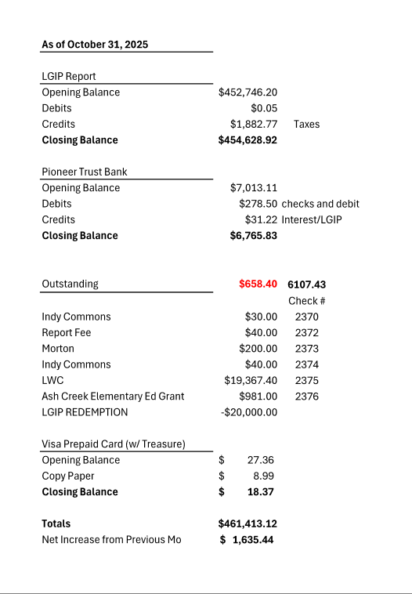
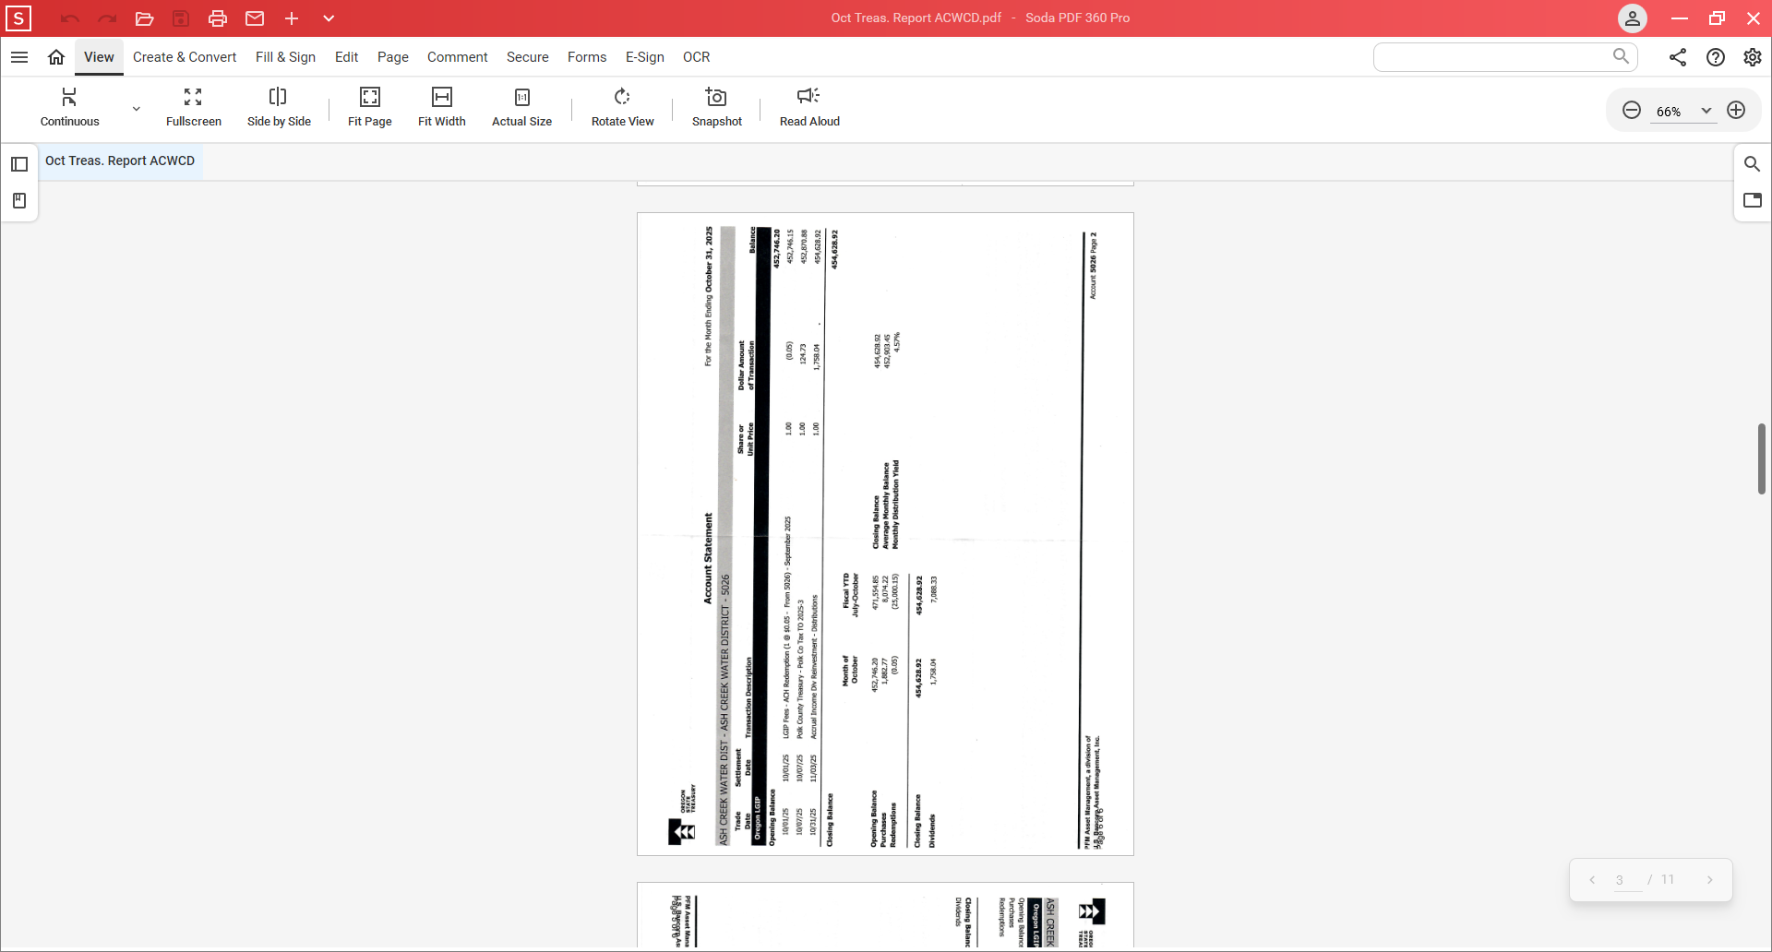

WITH ELECTION RESULTS:
Board of Directors, Positions & Terms after May 20 election

Mailing Address & Phone Number for all Directors:
PO Box 81, Independence, OR 97351, 503 779-9869

Director #1
Tom Wilson, President & Treasurer
Term: 2027
Email: director1@ashcreekwcd.com

Director #2
Vacant
Next election: 2027
Email: director2@ashcreekwcd.com

Director #3
Madeline Fisher
Term expires: 2029
Email: director3@ashcreekwcd.com

Director #4
Molly Barbano
Term expires: 2028
Email: director4@ashcreekwcd.com

Director #5
Brooke Getty
Term expires: 2028
Email: director5@ashcreekwcd.com

Director #6
Ed Matteo, Vice President
Term expires: 2027
Email: director6@ashcreekwcd.com

Director #7
Lauren Zatkos
Term expires: 2029
Email: director7@ashcreekwcd.com

Director #8:
Amy Albrich
Term expires: 2027
Email:
Director8@ashcreekwcd.com

Director #9
Position remains vacant
Term expires: 2029
Email: director9@ashcreekwcd.com

Content/Links for electronic correspondence:
From SDAO:
https://www.magnetmail.net/actions/email_web_version.cfm?ep=aiG7TXw8p6eAbFY-OXtJeeh-YEJi5KifS4hIjg748XoRBQ_mKDFBpF2kc6Wt76jC7RB7T2Kr8CTjTLgky8XzLnuLSJexiycXTRev4Rub_kKHvXdlAh5QrU9ar6DCu4c2
https://www.magnetmail.net/actions/email_web_version.cfm?ep=aiG7TXw8p6eAbFY-OXtJeeh-YEJi5KifS4hIjg748Xq2hgge2HyrzS2VJvs6QnWPIJVMcRcNYdobC8bNgkDHNKu8yb77AqCkEyogesTEYim2RwhNResfg9jLa8Vlmd5K
https://www.magnetmail.net/actions/email_web_version.cfm?ep=aiG7TXw8p6eAbFY-OXtJeeh-YEJi5KifS4hIjg748Xoqm0lupu_uIDPjCE_5v4y0OTCrg0HIbu9Vk69T_gw4DbXytlwpR3k_qmMX7nuELDnY_MgcZEL07_SJ6G6h_7ys
https://www.magnetmail.net/actions/email_web_version.cfm?ep=aiG7TXw8p6eAbFY-OXtJeeh-YEJi5KifS4hIjg748Xq8FI-wEmz0ojsx-i4WkqeD2tSkSvpuuCMV3AEz_qBGofZX5NpnP9eJG00Om2SiNuZ8asE3U0r2HcgR4kkiIIQK
https://www.magnetmail.net/actions/email_web_version.cfm?ep=aiG7TXw8p6eAbFY-OXtJeeh-YEJi5KifS4hIjg748XqUWbrDvADEfTHUSfbMdJ7k6hvE2ESAxAVGGs51o6J_XpcfwMz0Bj980i_DRVDn4Vs7W0PKHGAuoK2_3o4tC3o_
https://www.magnetmail.net/actions/email_web_version.cfm?ep=aiG7TXw8p6eAbFY-OXtJeeh-YEJi5KifS4hIjg748Xo1m_erWx7N_N7BqYU3spBhjKQgb6sqe4dJ1MfdFYS4R_aTpijh7t6iemo_T30BkW_WUc-jpKW1yJxHmvklEFXU
https://www.magnetmail.net/actions/email_web_version.cfm?ep=aiG7TXw8p6eAbFY-OXtJeeh-YEJi5KifS4hIjg748XqpFSGgGkGixA5Rj2sApjUtaGzJYGFUQj4a488LsY1qY7_1elIkGTN78sdCEgXqBuSlREQPFFisCA7JXXykpEQS
https://www.magnetmail.net/actions/email_web_version.cfm?ep=aiG7TXw8p6eAbFY-OXtJeeh-YEJi5KifS4hIjg748XpGPrVszEEKFW5UWQJTU_6ADykl9AK3KrSV7eehnr3YeaNZb70Gj6aYmjRxpNG12KTHAF3eOY8eUoMFsxHbmuZK
https://www.magnetmail.net/actions/email_web_version.cfm?ep=aiG7TXw8p6eAbFY-OXtJeeh-YEJi5KifS4hIjg748Xq8Sd03B45KnxZjvdJyMANrTFDevL2yCYquoVcUkym3X44gonrNMh_8pIddcYJr48kRdsCX7mh4H7Z4pxQ85bvO

